Digital Records
Guidance for Depositors

This guidance has been produced for anyone considering depositing or donating digital records to Gwent Archives. It will help to ensure that your digital records are well managed and are suitable for long-term preservation in an archive. Please contact us with any queries that have not been covered below, and we will be happy to advise.

A list of definitions has been provided at the end of the document in alphabetical order.

- What we accept
Gwent Archives accepts original digital items within the terms of the Archives and Library Collections Policies. Examples of material that are not “original” include
- Published material such as
  - Newspapers
  - Books
  - Ordnance Survey maps
  - Family History software
  - Digitized records such as parish registers if they are still available in paper format or accessible in our research room.
The Archive in most cases will only accept Born-Digital material. Examples include but are not limited to,
- Documents created on computer programs such as Word. This also includes things like spreadsheets, databases and emails.
- Photographs taken using a digital camera.
- Oral history recording/videos
- CAD drawings and 3D models etc.
The exception to the rule is the following,
- Digitized versions of archival material where it can be proved that the original paper record no longer exists. Or where significant annotations or edits have been made.
It is expected that most files will be open and available for research, but if they contain sensitive data about individuals, they will be closed in line with General Data Protection Regulations 2018.

File Formats
We can preserve a wide range of file types to ensure that any digital records transferred to Gwent Archives are accessible now and in the future. This includes but is not limited to:
- File formats produced by Microsoft products such as word, Excel, Access etc. Most text and document file types (For example, Open Document Text, Rich Text, Plain Text, PDF
- Images (For example JPEG, TIFF, PNG)
- Audio files (For example WAV and MP3).
- Video files (For Example MP4)
- Email files and inboxes (.msg, .pst)

We prefer to receive digital records in the file formats they were created and used in, even if that format is now obsolete. This is to ensure that the context is not lost, and data is not corrupted during processing. Changing formats could lead to loss of structure and information vital to understanding the information presented. Once the records are in our care, we may create access copies, but we will also retain the original version for archival purposes.
If you have any additional queries regarding formats, please contact Gwent Archives.

- Prior to Transfer

The following points below will help us to understand your records more easily and better manage their long-term preservation.
2.1 Making Sense of your Records
Tell us about your records - such as who created them, why they were created and what folder structure is in place - and this will help us to make informed decisions about them. It will also help us to better describe the records so that other people can access them in the future. If you hold any documentation about your records and how they were created, please provide us with copies. In most cases, only the final version of the document needs to be retained, with drafts and duplicates deleted prior to transfer. If you know the file size of your collection, then please do share this with us. If you are not sure how to do this then please see section 2.3

  - File Structure
Please retain your files within their original file structure whenever possible. To make the deposit process easier, we recommend that you move all the folders and files you wish to deposit into a single new folder. This can either be zipped or left unzipped. This will not only make it easier to deposit but will also make it easier to determine the size of your deposit.

2.3 Can you deposit your digital material from home or place of work?

Yes. Gwent Archives can even take deposits from mobile phones and tablets remotely but there are some caveats that you will need to consider

- Are you confident using a computer and the internet?
- Is your material on a device already? (Computer, Laptop, Phone or Tablet)
  - If it's on a storage device such as a USB stick, CD or Floppy disc, do you have the means to extract the material from these devices onto your computer or device?
- Do you have an email address?
- Do you have a stable internet connection? If so, do you think it is fast enough to upload the quantity of material you wish to deposit?
- Is the entirety of the material you wish to upload fewer than 50 Gigabytes?
  - Also be aware that the speed at which you can deposit material remotely with us depends entirely on the upload speed of your internet connection. The slower your upload speed and/or larger your collection the longer it will take you.
  - If you are unsure of the size of your collection, then please see section 2.4.

If the answer to any of the above is no, then please inform us. We can make arrangements to have you either visit in person with your material or have the material delivered to us by post.

If you answered yes to all the above, then you will be able to use the process outlined in section 3.2

2.4 Determining the size of your digital records

Please make us aware if you intend to deposit over 50GB of material. If you are unsure about how to determine the total file size, please follow the guide below which is applicable to material stored on a PC or can be accessed by a PC (A USB stick for example)

- Open your computer’s file explorer and navigate to your material. Ideally, we prefer all the material you wish to donate to be collected in one folder. This allows you to more easily find out the total file size of the collection you wish to deposit. Once you have found your folder of material, right-click it. This will bring up a drop-down menu. You will need to then click on properties.

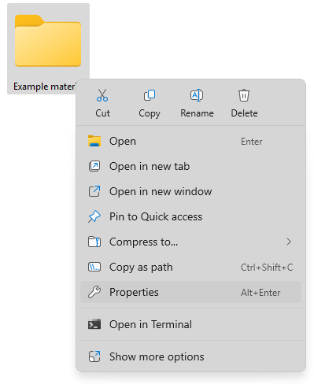
- You can see in the image below that once we click on properties, a new menu will appear. This menu gives us information on all the material within the folder. For our purposes, we will need the size. You will see that there are two figures given for size, for this we will need the size on disc. In this case this is 5.14 Megabytes (MB)
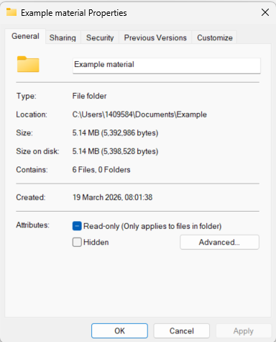

- You will need to make a note of the size and share this with the archivist.

- Transferring your records
3.1 What if I cannot deposit material remotely?

If you answered no to any of the questions in section 2.3, please inform the archivist. They will arrange for you either to visit the archive in person or if travelling to the archive is not possible, then the archivist will ask you to have the material delivered by post.

Currently we accept USB sticks, USB storage devices, Hard drives, Solid state drives (SSD), SD cards, CD/DVD, Floppy disc and Cassette tapes. If your material is stored in a different storage format, please do make us aware.

Files can be compressed (zipped) to assist transfer and to allow important information such as file creation data to be maintained. Passwords may be used for sensitive data, and the password should be provided separately on the accompanying paperwork.

The Archivist will take your digital material and process this using our own hardware. This can take up to 10 business days depending on the complexity of the material.

If the archivist encounters any issues with processing your collection, then they will inform you and discuss next steps.

If there are no issues the archivist will issue you with a receipt once your material has been uploaded into our digital preservation system.

3.2 What If my deposit is fewer than 50 Gigabytes?

If the answer to all of the questions in section 2.3 was yes, then we can use our Preservica system to allow you to deposit your material remotely from home or your place of work. Please follow the instructions below. If you encounter any difficulties, please make the archivist aware, and

- Inform the archivist that your collection is under 50GB.
- The Archivist will then inform you to expect an email from Preservica
- Keep an eye on your inbox for an email from Preservica. Please be aware that this may end up in your spam folder.
- You should receive an email. Once opened it will look like the image below,
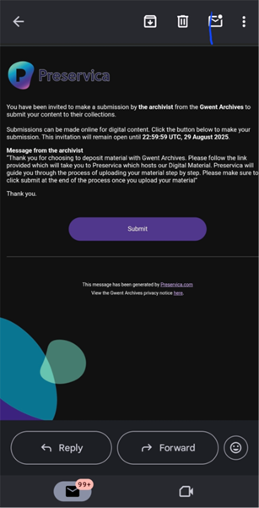
- Click on the submit button near the bottom of the email. This will take you to a page that looks like this,

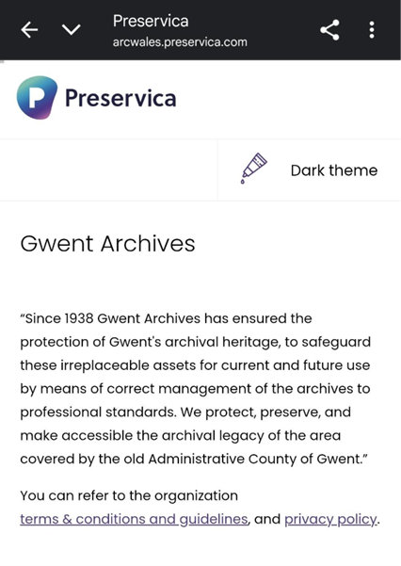

- At the bottom of the page, you will see two boxes where you will need to enter your name before agreeing to the terms and conditions and clicking “Next step”
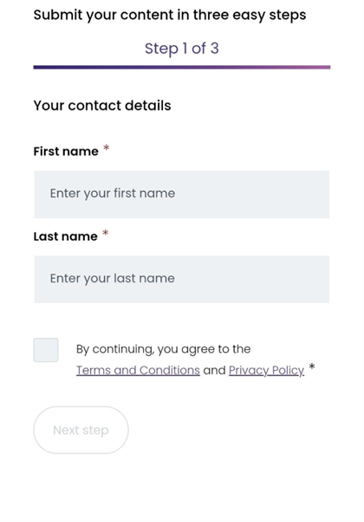
- You will then be presented with a new page where you will need to enter the name and a short description of the material that you are depositing. This does not need to be a long description; this is simply to help our staff identify your deposit.
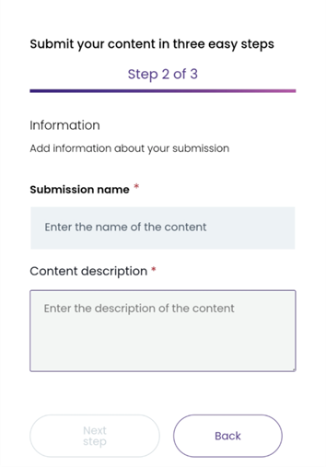

- Once you have entered the name and description of the collection, please click “Next step”.

- You will then be presented with a screen like the images below. You will have the option either to click and drag your folder of material into the relevant box. Or you can select “folder” or “File”. This will open the file explorer on your device, and from here you can select the folder which contains your material. Once you select your material, Preservica will get to work on uploading it to our archive.

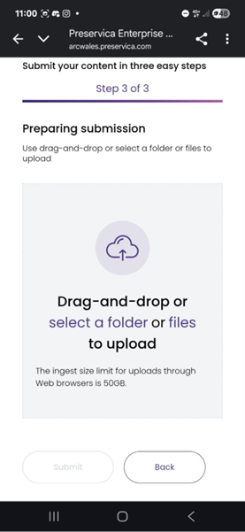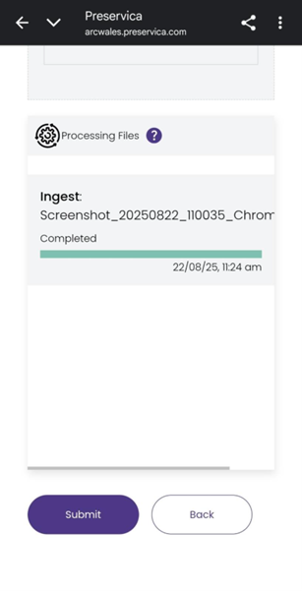

- Please leave this page running while your material is uploading. The length of time it takes for your files to upload depends on your Internet speed and the total size of the material you are depositing. Once the loading bar is full Preservica will allow you to click the “Submit” button. Please make sure to click this before leaving the page otherwise we will not receive your material and you may have to start again. If for any reason this is taking longer than 1 hour please stop the process and inform the archivst.

Please be aware of the following,
- As long as your computer is “Active” In other words it does not lock or go to a screensaver you should be able to use your device for other tasks while you wait for the upload to complete. If you wish to walk away from your computer while this process is ongoing then please make sure that you edit your computer’s lock screen settings
  - On Windows 11 this can be done by going to the search bar at the bottom of your screen. Search for “Lock Screen” and you should be able to see
  - Please remember to undo these settings once you have finished uploading your material.
- If you are on a mobile, tablet or similar device then you will need to keep the process running. If your mobile or tablet has a lock screen the timer for this can normally be turned off within your settings. This varies from phone to phone but is only neccersary in cases where you think your material will take a long time to upload.
- If you encounter any issues with the upload, then please contact us at enquiries@gwentarchives.gov.uk . Gwent Archives staff will be able to assist you or will suggest you either bring in or post the material to us.

- Deleting your copies
We recommend that you retain copies of your material until we confirm that the files have been received and processed successfully. Please note that we cannot return digital items that we decide not to keep. We assess digital material in line with our Archive and Library Collections Policies so that the same criteria are applied to records regardless of the format in which they exist.

Definitions:

- Born-Digital – A term used to describe material that was originally made on a computer or similar device. A photograph taken on a phone or digital camera would be born digital, however a photograph taken on a camera that uses film would not be born digital even if it were subsequently scanned into a computer.
- Encryption – A method that is sometimes used to keep information secure. It works by “Scrambling” the data. This data can then be unscrambled using a key or password set by the computer. In most cases digital material is not encrypted.
- Gigabyte – A unit of measurement used by computers for storage space, often abbreviated to GB.
- Original Material – In this case this refers to items that have always been in a digital format, for example a photograph or video take using a digital camera. Or a Word document.
- Preservica – An online service used by Gwent Archives to preserve digital material and allow for deposits to be given to us remotely, for example from home or your place of work.
- File Structure – The way in which your files and folders of digital material are arranged. Gwent Archives prefers the file structure to remain the same as it was when originally in use as this provides useful context.
- Storage space – The “Size” of a file normally depends on how complex it is. For example, you could possibly fit thousands of word documents into a Gigabyte, especially if they are purely text based. However, a high-quality film may take up several Gigabytes.
- Upload speed – How fast your internet connection allows you to transfer material out of your computer and into a different location on the internet. For example, it would determine how fast you could place a photograph on a Facebook page, or video onto YouTube. It is the reverse of Download speed which determines how fast your internet allows you to take material off the internet into your computer.
- Zip Folder – A method of making digital material temporarily take up less storage space. Normally this is used to make transferring material, such as by email, easier. This is normally represented on a computer with an icon of a folder with a zip like so -
