Gwent Archives Agreement Terms
1. Introduction 1
2. Definitions 1
3. The Archive Agreement form 2
4. Legal Section 7
4.1 Methods of Acquisition 7
4.1.1 Deposit 7
4.1.2 Gift 8
4.1.3 Transfer 8
4.2 Depositor Undertakings 8
4.3 Gwent Archives’ Undertakings 9
4.3.1 Preservation 9
4.3.2 Cataloguing 10
4.3.3 Access 10
5. Data Protection 11

1. Introduction:
Gwent Archives’ mission is to collect new records, preserve them for posterity and make them available for wider public consultation. In accepting new material, Gwent Archives requires all donors/depositors to complete an Archive Agreement form.
This document explains each section of the Archive Agreement form and clarifies the terms under which Gwent Archives accepts archival documents. These terms also include the undertakings of both the Donor/Depositor and Gwent Archives.
If anything remains unclear, please contact Gwent Archives before giving / depositing your records with Gwent Archives at enquiries@gwentarchive.gov.uk

2. Definitions:
Within this document and the Archive Agreement form are terms, which we realise may come across as jargon. This section provides definitions for these terms
Acquisition: how Gwent Archives obtains records, whether by Gift, Transfer of Deposit.
Archives: original records which have been selected for permanent preservation because of their continuing value.
Data Controller: Gwent Archives holds records from various organisations and administers access to those records. In some cases, the primary decision-maker will be an external organisation, e.g. access to some school records will be the responsibility of the relevant local authority rather than Gwent Archives.
Deposit (Loan): Custody of and responsibility for archives/records are transferred permanently to Gwent Archives, whilst the depositor retains legal ownership.
Depositor: An individual or organisation, who deposits archives/records with Gwent Archives.
Digital records: This may include both born-digital records and records digitized from paper records.
Donation: see Gift
Donor: An individual or organisation who gives, bequeaths, or sells archives/records to Gwent Archives.
Gift: a permanent transfer of ownership of archive/records. Legal rights both physical and intellectual (where this is the property of the donor) are automatically transferred to Gwent Archives. Gifts may also include bequests and purchases. (Also called a Donation)
Records: record information in any medium created or received and maintained by an organisation or person in the transaction of business. NB not all records are archives; some records still have current/semi-current usage.
Surrogate: any copy of an original record, irrespective of media. (This can include: photocopies, digital scans, microfilms, etc.).
Transfer: Records may be transferred to Gwent Archives by one of its 5 parent authorities

3. The Archive Agreement form:
This section goes into detail on what donors/depositors need to include within the form.

Header:
Please leave this blank. Gwent Archives will complete this section.
Accession Number: each new record or collection of records we receive is allotted a unique number. You will receive this Accession Number as part of a separate Receipt, which Gwent Archives issues following the physical gift/deposit.
Date: this is the date on which Gwent Archives physically receives the collection and accepts it

Contact Details
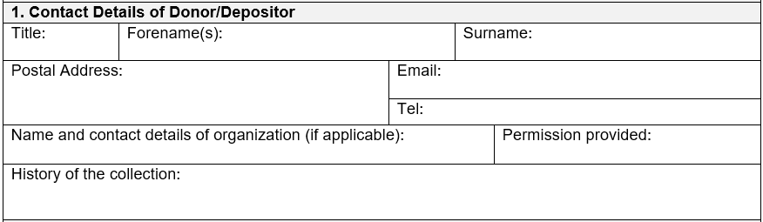
Gwent Archives may receive archives from individuals or organisations.
If the collection is being given to/deposited with Gwent Archives by an individual, then they complete the form on behalf of themselves.
If the collection is being deposited with Gwent Archives by someone representing an organisation/group/society, then the form needs to be completed on behalf of the organisation. Gwent Archives will also need evidence that they are entitled to do so, e.g. a letter of authority from a principal officer such as the Chair of that organisation or copy of a minute confirming the deposit.
Photographic proof of identification may be requested from the individual depositing the collection.
History of the Collection: this section is there for the depositor to provide a history of the ownership of the collection: where/with whom the records have been held since they were created.

Details of records
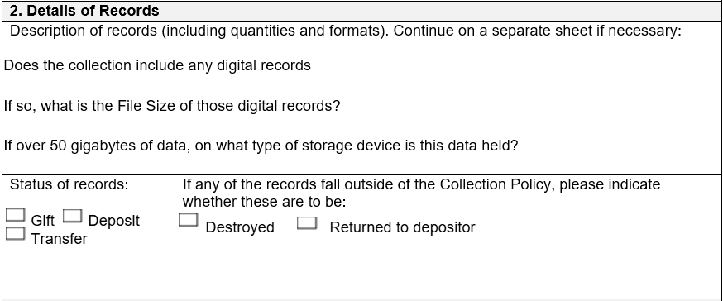
Description of records: Gwent Archives requires an overview of what is being transferred, including types of record, date range and quantity. E.g. Govilon WI minute books, 1922-1974, 6 volumes.
Status of records: one of the following needs to be ticked:
- Gift: the collection becomes the property of Gwent Archives

- Deposit: Gwent Archives looks after the collection and administers it; however, the Depositor retains ownership

- Transfer: Gwent Archives acts as the official repository for the 5 local authorities we serve. Archival records from these should be transferred to Gwent Archives
(Section 4 explores these terms in more detail, and the undertakings of both Gwent Archives and the Depositor).
Gwent Archives accepts Digital records. Please indicate whether any of the deposit is in a digital format. In most instances digital deposits (under 50 Gigabytes in size) may be uploaded into our system by you at home; Gwent Archives will send you a template and instructions how to complete this process. Where this is not possible, please inform Gwent Archives:
- The quantity in Gigabytes of the records
- If over 50 Gigabytes, within what medium the records are held, e.g. are they on a flash drive or another device

The Archives Collection Policy: archivecollections2025venglish.docx provides the criteria under which we accept/decline records. On occasions after we go through an accession, we may discover that there are items which fall outside of this, and we shall not retain. Gwent Archives needs to know what to do with unwanted items:
If any of the records fall outside of the Archives Collection Policy, please indicate whether these are to be:
- Returned to Depositor: depositors may collect their records.

- Destroyed: Gwent Archives will destroy items appropriately, e.g. via Confidential Waste. Destruction is an irreversible act, so will only be considered if authorised by the depositor.
If the item(s) offered to Gwent Archives fall outside of our Archive Collections Policy but may be relevant an organisation such as another County Archives or local Museum, then Gwent Archives will help to identify potential recipients.

Data Protection
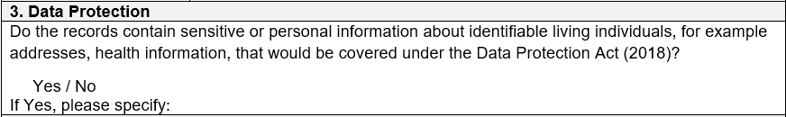
Are any of the records subject to restricted access or any other special condition?
Do the records contain sensitive or personal information about identifiable living individuals, for example addresses, health information, that would be covered under the Data Protection Act (2018)?
Gwent Archives aims to make the records it collects available for wider public consultation. However, Gwent Archives needs to ensure that it does not compromise the personal data of living individuals.
Where known the donor/depositor should inform Gwent Archives at the time of gift/deposit of any known sensitive or personal information within the records. Where archivists subsequently discover this information, then they will restrict access in accordance with legislation.
(This is explored in more detail in section 5 of this document)

Copyright of the records
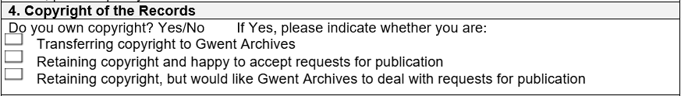
This section deals with copyright. Copyright is held usually by the creator rather than the owner of a document. E.g. if you and another person exchanged a number of letters, you may own the letters you received, but if they were written by somebody else, then that person will still own the copyright.
Copyright is a complex subject, e.g. not all documents are in copyright; or, sometimes copyright is owned by an heir of the creator. Therefore, where you know to the best of your ability, please confirm whether you own the copyright. Gwent Archive staff are happy to discuss any queries you may have and provide advice around copyright.
If you do believe you own the copyright, then we also ask you to confirm whether you are:
- Transferring copyright to Gwent Archives: this means that the copyright will now belong to Gwent Archives

- Retaining copyright and happy to accept requests for publication

- Retaining copyright but would like Gwent Archives to deal with requests for publication (Sometimes a researcher will wish to use an image of an original document in a publication. This is looking to confirm whether you would like the researcher to contact you directly or go through Gwent Archives).

Conservation
Some documents which arrive with us are in a poor condition. Our Conservator may need to carry out treatments on these, e.g. stabilising paper documents with Japanese tissue and wheat starch paste adhesive. Treatments of this nature ensure that an item can be used by researchers and reduces the potential of further damage.

Surrogates
In some instances, Gwent Archives will want to provide access to the information contained within a document but will not want to risk damage to it. For example, we may wish to take a digitized copy of a fragile document, which will be made available to customers in place of the original. This would prevent excessive handling and further damage to that original.
In this section we are requesting your permission to do so.

Agreement
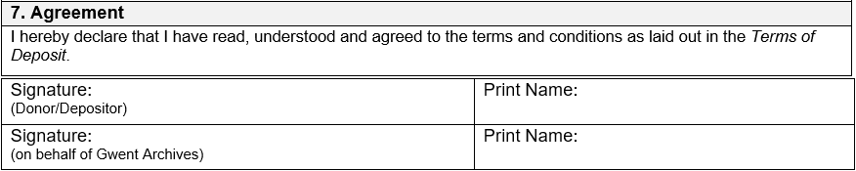
This is where you sign that you agree with the terms; and we countersign.

Section on background:
This allows for you to add anything else not covered by the Archive Agreement form, e.g. any background and/or history about an organisation, person or family.

4. Legal Section:
By signing this agreement, the donor/depositor needs to be aware to what they are agreeing. Section 4 outlines definitions in more detail and the undertakings of both the depositor and Gwent Archives.

4.1 Methods of Acquisition:

4.1.1 Deposit
4.1.1.1 “Depositor” means any person or organisation placing records on deposit, or their lawful heir, personal representative or successor in title.
4.1.1.2 “Deposit” means that the party named in the signed Archives Agreement form, as the depositor, has placed the records listed on that agreement in the custody of Gwent Archives. This in no way alters or otherwise affects the ownership of the records.
4.1.1.3 A Deposit is deemed to be for an indefinite period, unless agreed at the time of deposit by both Gwent Archives and the depositor.
4.1.1.4 All records are accepted in good faith. The depositor is deemed to be entitled to deposit the records, either as owner or agent and will be required to prove their right to deposit the records to the satisfaction of Gwent Archives. In the case of an organisation, this may involve a letter from a principal officer, or a copy of a minute confirming this.
4.1.1.5 Records may be reclaimed by the Depositor under the terms specified in Sections 4.2.5 and 4.2.6 of this document.
4.1.1.6 Gwent Archives reserves the right, either at the time of deposit or subsequently, to dispose of any records, which fall outside of its Archive Collections Policy. With the consent of the depositor, they will either be returned to the depositor, transferred to a more appropriate place of deposit or destroyed confidentially.

4.1.2 Gift
4.1.2.1 Records already placed on loan can be gifted or made the subject of a bequest to Gwent Archives at any time.
4.1.2.2 All records are accepted in good faith. The Donor may be asked to prove their entitlement to donate records to Gwent Archives.
4.1.2.3 The Donor will at the time of Gift sign the Archive Agreement form, and the records transfer to the ownership of Gwent Archives.
4.1.2.4 Records given to Gwent Archives become the property of Gwent Archives. They cannot be turned into deposits or withdrawn from Gwent Archives.

4.1.3 Transfer
4.1.3.1 Gwent Archives is the official archive for its constituent authorities: Blaenau Gwent County Borough Council, Caerphilly County Borough Council (the former Islwyn Borough Council area), Monmouthshire County Council, Newport City Council and Torfaen County Borough Council.

4.2 Depositor Undertakings
4.2.1 It is the Depositor’s responsibility to notify Gwent Archives if there is any change in name and/or address of either the Depositor and/or owner of the records. Gwent Archives will not accept responsibility for any consequences which may arise from the failure to notify such changes. This is important since Gwent Archives may need to liaise with the depositor in future, e.g. if there is a transfer of ownership (through bequest/sale); or, if the depositor is data controller of the records deposited.
4.2.2 Whilst Gwent Archives’ building is insured, Gwent Archives does not insure collections within its care. If depositors wish to insure their collection(s) independently and at their own expense, then they are entirely at liberty to do so.
Please note that Gwent Archives does take mitigating actions to protect records in its care:
- Records are stored in locked, environmentally controlled strong rooms in compliance with BS 4971:2017
- Records within strong rooms are placed in acid-free packaging
- Records are only consulted by researchers who have registered with the Archives Card Scheme, or Gwent Archives’ own internal registration system
- Records are only made available in a controlled environment, where staff invigilate the use of those records, including the correct handling and security
- Records are subject to an audit trail of who uses which document through a document issuing system

It is the responsibility of the depositor to check whether any of the above mitigating actions affects the terms of any insurance policy for their records.

4.2.3 Creating organisations of records deposited/transferred to Gwent Archives (and their successors) will continue to act as Data Controllers of those records. The depositor and Gwent Archives will agree how requests for data from restricted records will be processed.

4.2.4 To the satisfaction of Gwent Archives, the Depositor may be required to provide evidence that they have the authority to deposit and subsequently withdraw records.

4.2.5 The Depositor may withdraw their deposited archives. They will need to make the request in writing giving details of which archives items they wish to withdraw and for how long. Unless agreed otherwise at the point of deposit, then Gwent Archives will require a minimum of 15 working days to process the request, e.g. to allow conservation assessments to be carried out. Gwent Archives accepts no liability for loss or damage of records while they are withdrawn.

4.2.6 The Depositor may also withdraw their records permanently. They will follow the same procedures as in section 4.2.5 and may convert a temporary withdrawal into a permanent one. If archives are permanently withdrawn, Gwent Archives reserves the right to levy charges to cover the costs of storage, cataloguing and conservation.

4.3 Gwent Archives’ Undertakings

4.3.1 Preservation
4.3.1.1 The records will be stored in the Gwent Archives’ strong rooms. They will be stored in environmental conditions conforming to BS4971: 2017, the Standard for Conservation and Care of archive and library collections. Please see Gwent Archives’ Collections Care and Conservation Policy for the principles that guide the preservation activities of the service: collectionscareandconservationvenglish.docx
4.3.1.2 Gwent Archives will take all reasonable precautions to preserve the records from damage, loss or theft but will not otherwise be liable beyond this to the depositor for any damage to or loss or theft of records during the deposit period
4.3.1.3 Records may be packaged, conserved, rebound or otherwise subjected to further treatments that are deemed necessary by Gwent Archives in the interests of preservation.
4.3.1.4 In giving unique reference numbers to individual documents, staff at Gwent Archives may write these on the document in pencil.
4.3.1.5 Digital records will be stored in the Preservica Digital Preservation System. Gwent Archives reserves the right to store, archive, copy, or migrate the digital object/information object for preservation purposes to ensure future accessibility. Further information is available in the Digital Preservation Policy.

4.3.2 Cataloguing
4.3.2.1 The Archive Agreement form is issued automatically along with these Terms of Deposit for any archives deposited with/given to Gwent Archives. A formal receipt will be issued within 10 days of receiving the records.
4.3.2.2 The records will be catalogued according to the Gwent Archives’ Prioritisation Scheme for cataloguing records in its custody, and in accordance with Gwent Archives’ Collections Manual, which adheres to current standards for cataloguing archival collections.
4.3.2.3 Gwent Archives reserves the right to request that the Depositor or Donor provides a listing of the content of the records.
4.3.2.4 Gwent Archives will make the resulting catalogue available online. This will be placed on Gwent Archives online catalogue: Gwent Archive Catalogue, as well as the Archives Hub: Home - Archives Hub and Discovery: Discovery | The National Archives portals.

4.3.3 Access
4.3.3.1 Subject to any exemptions agreed in 4.2.3 records (including born digital records and (digital) surrogates) will be made available to customers for the purposes of research free of charge at Gwent Archives during advertised opening hours and in accordance with Gwent Archives’ Research Room Rules. Surrogates may be made available in a variety of ways including via the internet in partnership with other organisations, subject to copyright, or unless agreed differently at the time of deposit.
4.3.3.2 Restrictions may be placed on public access to individual records due to preservation needs or to ensure compliance with relevant legislation, including GDPR (General Data Protection Regulation)
4.3.3.3 Single copies of documents will only be supplied to customers provided it is consistent with the safety of the records and in compliance with current copyright law.
4.3.3.4 If a researcher wishes to use copies of Gwent Archives’ records in a publication or broadcast, then responsibility for obtaining copyright clearance rests with them. They will also pay an appropriate fee to Gwent Archives for use of the records. These are detailed in Gwent Archives’ Services and Charges document, available at Fees and Charges | Gwent Archives
4.3.3.5 Deposited records will only be loaned to a third party with written permission of the Depositor.
4.3.3.6 Subject to proper regard for security and preservation, archives/records may be removed temporarily from their normal place of custody at the discretion of an Archivist or Conservator. In the case of temporary removal from Gwent Archives, the consent of the depositor will be sought.
4.3.3.7 At the discretion of the County Archivist or one of the Senior Archivists, staff may check records for information when requested to do so by the Depositor. For a quick enquiry, there will not be a charge for this service. However, normal fees will apply, if:
- The request does not come directly from the Depositor
- The information is being supplied to a third party
- The request proves too time consuming

4.3.3.8 No charge will be made for a depositor to photograph their own records within Gwent Archives’ Research Room.

5. Data Protection
5.1 Records containing sensitive or personal information about identifiable living individuals, for example addresses, health information, that would be covered under the Data Protection Act (2018), will ‘be closed to the public. Please see Gwent Archives’ Access Periods Guidance for examples: accessperiods_2025_03_27.docx
5.2 A Data Subject, or a person acting on their behalf, will have a right to their own data within Gwent Archives’ records. This will be dealt with as a Subject Access Request. As detailed in section 2, in some cases, the Data Controller (the primary decision-maker) will be an external organisation.
5.3 Whilst Gwent Archives will endeavour to observe any agreed restrictions on access, the donor/depositor understands and acknowledges that Gwent Archives, as a public service, might be obliged to provide information contained in the archives/records under the Freedom of Information Act 2000.
5.4 For the role of Data Controller, please see 4.2.3
5.5 Access to the donor/depositor’s details is restricted to staff at Gwent Archives. Personal details will not be divulged to a third party or appear in any public finding aid unless permission has been given by the donor/depositor. The personal information of the donor/depositor will ordinarily be retained permanently by Gwent Archives. Please see Gwent Archives’ Privacy Policy: https://www.gwentarchives.gov.uk/en/privacy-policy/

These terms were written in August 2026 and will be reviewed annually or sooner if circumstances dictate.

