Neurodivergent Access Guide to Gwent Archives

What is this guide?
This guide has emerged from discussions between neurodivergent archive, library, and collections users and professionals. It contains what we hope is useful information for anyone who identifies as neurodivergent, although a lot of the information will be of use generally. We have tried to collate it into one space to make the process of coming to our archive more accessible, but we are aware that you might have further questions. If so, please get in touch with us at enquiries@gwentarchives.gov.uk

How can I use this guide?
This guide begins with basic information about where you can find us, before moving onto a section structured loosely in chronological order of what you need to do before arrival, and information that will be of use on the day. Later sections include information about bathrooms, where you can eat or buy food and drink, sensory information, research room etiquette, and where our quiet spaces are. Feel free to skim the whole document, or narrow in on sections that are useful to you.
Table of Contents
Neurodivergent Access Guide 1
What is this guide? 1
How can I use this guide? 1
Why is this guide important? 2
Basic Information 2
What to do before a visit 3
On Arrival 5
In the Research Room 10
Ending Your Visit 12
Bathrooms 12
Food, Drink and Break Rooms 13
Sensory Information 14
Light 14
Temperature 14
Noise 15
Smell 15
Visual Distractions 15
Our Research Room Etiquette 16
Quiet Spaces 17
Who was this guide developed by? 17

Why is this guide important?
The term ‘neurodivergent’ emerged from autistic activism, designating those whose style of thinking, communication, or processing information diverges from the accepted norm, such as people with ADHD, autism, dyslexia, Tourette’s, dyscalculia, or learning disabilities. With 15-20% of the UK population estimated to be neurodivergent, there are many people who would benefit from having greater information about what to expect ahead of visits to archives, libraries, and collections.

Basic Information
Gwent Archives
Please contact us if you have any questions before your visit, please feel free to email us at enquiries@gwentarchives.gov.uk 01495 766261

Opening Times
Monday – Closed
Tuesday to Friday - 9:30-12:30, 13:30-16:30

Address
Gwent Archives
General Offices
Steelworks Road
Ebbw Vale
NP23 6AA

Gwent Archives is located in a larger, shared, building called the General Offices. It is shared with Blaenau Gwent County Borough Staff and Ebbw Vale Works Museum.
There are two entrances, one stepped entrance at the front alongside the main road (on Steelworks Road), and a step-free entrance at the back (on Ffordd Billy Collins).
The archive can be reached by private transport, bus or national rail. There is limited, free, parking close to the General Offices with accessible spaces and 6 Type 2 (7.5kw) electric charging points. Ebbw Vale Town train station is situated next door to the General Offices, and regular trains operate from Cardiff Central and Newport stations, and Ebbw Vale is well service by local buses. More detail can be found on our transport pages https://www.gwentarchives.gov.uk/en/visiting-us/location-and-opening-hours/

What to do before a visit
You do not have to book a space to look at historical documents, but you are welcome to book and pre-order documents if you prefer.
- You can book an appointment in advance if you wish, or you can just walk in.
- If you know what documents you want to use please let us know the reference numbers and we will get up to 6 items out ready for your visit. You can do this by emailing us at enquiries@gwentarchives.gov.uk
- Some of our catalogues are available online at https://www.gwentarchives.gov.uk/en/our-collections/archives/ but some are only available in hard copy at Gwent Archives so please contact us at enquiries@gwentarchives.gov.uk if you cannot find what you are looking for or would like advice from staff.
- Some of our catalogues are also available on Archives Hub at https://archiveshub.jisc.ac.uk/ and The National Archives Discovery catalogue at https://discovery.nationalarchives.gov.uk/
- Resources and guides are also available on our website at https://www.gwentarchives.gov.uk/en/our-services/resources-and-guides/
- You can request the following things when you book: height-adjustable desk, a seat near the window. Our chairs are computer-style chairs, are height adjustable and some have arms but some do not. If you are using our computer resources you can request an ergonomic mouse. Please tell us your requests when you contact us to book.
- If you need to bring your own equipment please let us know in advance so that we can plan the space and be available to help if needed
- If this is your first time visiting our archive you will need to sign up for an Archives Card if you do not already have one. You can sign up at www.archivescard.com. Don’t worry if you haven’t been able to sign up in advance, or forget your documents, we can issue a temporary card that is valid for the day of your visit.
- If you are bringing a companion with you to the building they will also need to sign up for an Archives Card.
- We use lockers and you will have to put your coat and bag in one before you go into the research room. These are free to use, and the keys are kept in the locker. Our lockers vary in size, see photograph below, and have a turn key that you will keep with you during your visit.

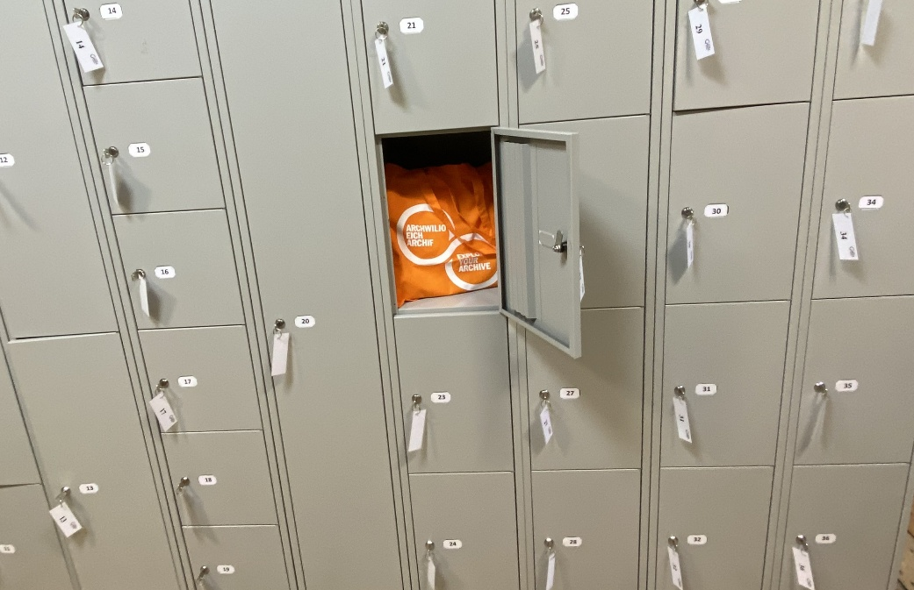
Image 1: Lockers in the Locker Room
An appointment is not required, but if you would like to book
- email us at enquiries@gwentarchives.gov.uk or telephone us on 01495 766261. We require 5 working days’ notice if you would like to order documents to be ready for you when you arrive. If the material is uncatalogued we require 7 working days’ notice, which allows us time to check the condition and content of the collection.
- include in the email any reference numbers of documents you want to see, if known
- include any equipment or requirements, for example a height-adjustable table, a seat away from the window
A member of staff will respond to confirm or discuss your booking and requests.
You will also need to get an Archives Card. This can be done in advance of your visit by:
- Using the website https://www.archivescard.com/ to apply for a card
- Uploading a photograph to the application
- Bringing with you two forms of identification from the list provided on the Archives Card website https://www.archivescard.com/
- A member of staff will then issue you with your Archives Card when you arrive at Gwent Archives.
If you are not able to register online in advance we will register you and take your photograph when you arrive.

On Arrival
The entrance at the front of the General Offices, on Steelworks Road, is stepped. You will need to ring the doorbell on the right-hand side of the door a member of staff will unlock the door remotely via a button under the reception desk and you can push the door open. There is a small dark grey rectangular panel to the left of the door that will have a flashing green light when the door can be opened.

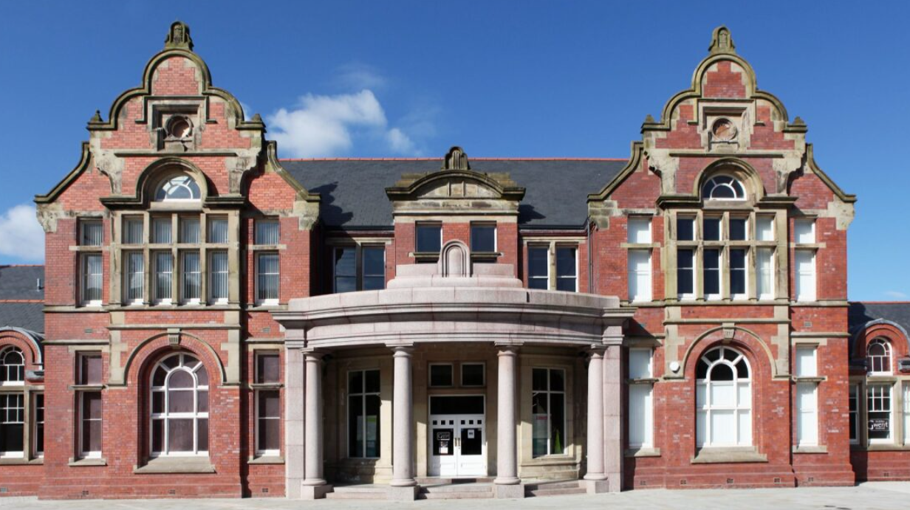
Image 2: The front (stepped) entrance to The General Offices
Once inside, the Reception desk is on your right and a member of staff will direct you to Gwent Archives. In front of you will be a large stone staircase
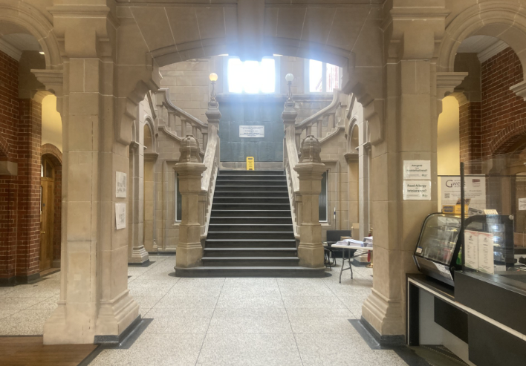
Image 3: The stone staircase, with Reception on the right
At the bottom of the staircase turn right, walk through the open double-doors and towards the long corridor.

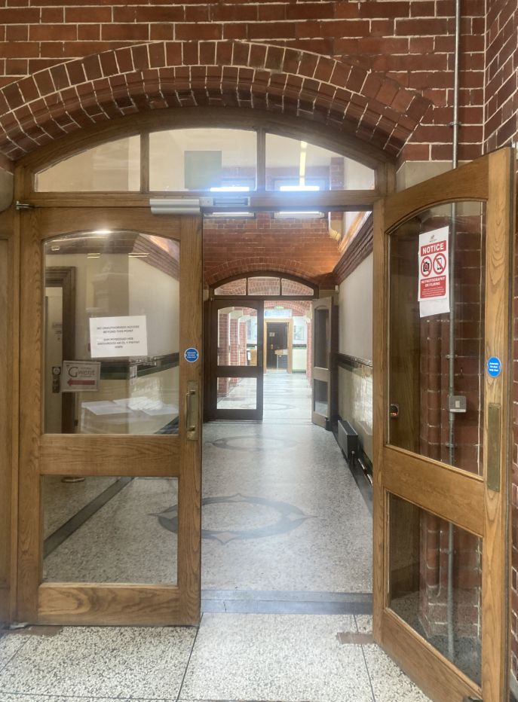
Image 4: open double-doors to long corridor
The Research Room and the Locker Room are immediately on the left of the double-doors and are signposted. The Research Room is straight ahead, and the Locker Room on the right.
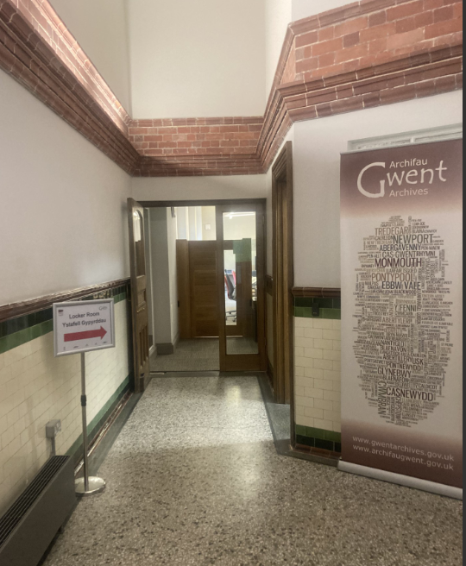
Image 5: Entrance to Gwent Archives

If arriving at the back of the General Offices (on Ffordd Billy Collins) you will need to ring the doorbell on the left-hand side of the door. There is a camera on the doorbell and a member of the Reception staff may speak to you through the door bell speaker. You just need to let them know that you are visiting Gwent Archives, they will unlock the door remotely via a button under the reception desk and the door will automatically open. A telephone number for the General Offices Reception team is displayed on the door if needed.

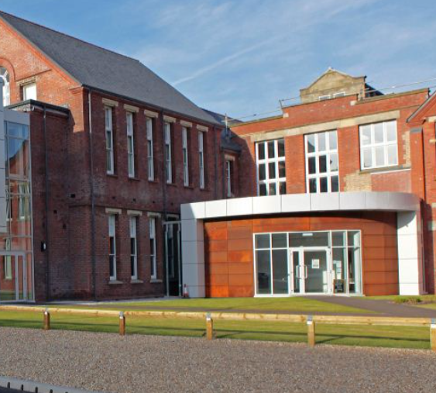
Image 6: Rear (level) entrance to the General Offices
Once inside you will walk through an area with table and chairs
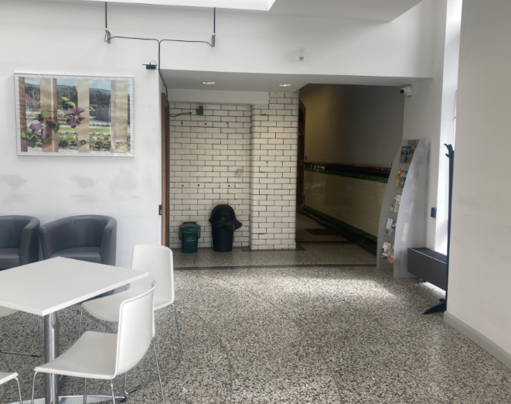
Image 7: Atrium area with tables and chairs
Walk straight ahead and through the corridor, and you will be at the bottom of the large stone staircase. Turn left to walk in front of the staircase, through the open double-doors into the long corridor
Image 8: open double-doors to long corridor
The Research Room and the Locker Room are immediately on the left of the double-doors and are signposted. The Research Room is straight ahead, and the Locker Room on the right.
Image 9: Entrance to Gwent Archives
Before you come into the research room, put your coat and bag in a locker. You can take your laptop and charger, and a pencil and notebook with no loose sheets into the Research Room.

In the Research Room
The research room is open Tuesday to Friday between 9:30 and 12:30 and 13:30 and 16:30.
First, go to the archives desk and check-in. When you enter the room there will be a service desk that you will come and tell the staff your name.
If you have had to register for an Archives Card you will be asked to show some documentation. A member of staff will take your photograph if you have not already uploaded one and will then issue your Archives Card. If you already have an archives card you will be asked by the member of staff at the desk to see it. They will scan the barcode and return your card to you.
- If you have not already done so you will be asked to put your bag and coat into a locker. These are free to use, and the keys are kept in the locker.
- You will not be given an assigned desk, you can choose where you would like to sit
- If you have ordered materials in advance they will either be brought to your desk on a trolley or each item is brought to you as you need it, depending on the format of what you have ordered. For example volumes will be on a trolley on arrival, but if there are lots of loose papers they will be issued bundle by bundle as needed. Just let a member of staff know when you are ready for the next bundle. Any equipment such as weights and support cushions will also be ready for you on arrival.
- If you have not ordered materials a member of staff will show you the catalogues and finding aids and talk you through how to order documents. More information about this is in our Research Room Guide at https://www.gwentarchives.gov.uk/media/ihmps0fe/researchroomvenglish.pdf
- When you are finished with your materials, let a member of staff know and they will return them. Repackaging some items can be tricky, especially items wrapped in thick paper, so ask a member of staff if you want assistance. They will also be happy to do it for you!
- Last ordering of materials is half an hour before closing time.
- Photography of our items is permitted, without using a flash, and you will need to fill in a form which tells us what you are photographing for our records and purchase a Photograph License. You can ask for the form at the archive desk, and payment can be made by card, with cash or cheque. The current cost of a Photograph License can be found at https://www.gwentarchives.gov.uk/en/fees-and-charges/
- This archive may require you to show your open laptop or notebook to anyone when leaving the research room.
- Our research space has seating for 24 people, with 6 tables that sit 4 people each and 1 large table for use with maps. There is 1 height adjustable desk which can be booked by emailing enquiries@gwentarchives.gov.uk
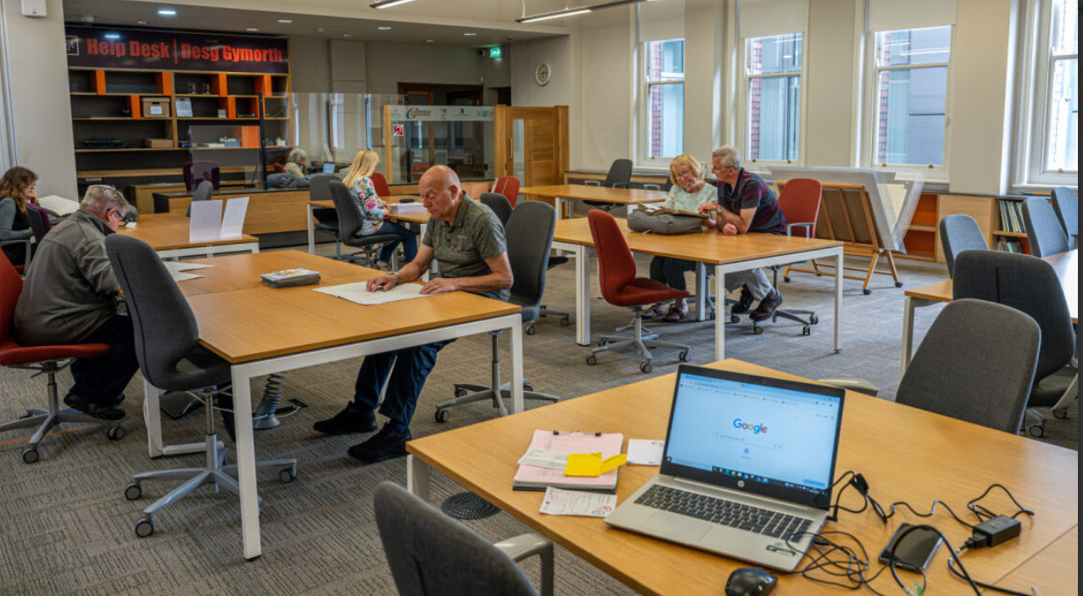
Image 10: Research Room
- We understand that some people have tics and might make sounds. You do not have to tell us about this, but if you want to you can inform the staff member at the research room desk. You are very welcome in our space.

Ending Your Visit
The research room closes at 12:30 after the morning session and 16:30 at the end of the day. Staff will remind you that the research room is closing 15 minutes before this and will request any archives you’re working on 10 minutes prior to closing. The locker room will not be locked until 16:40 to allow all researchers to retrieve their belongings after closure.
Between 12:30 and 13:30 the Research Room will be closed and you will need to vacate the room. You are welcome to relax in the Locker Room, where there is a table and chair, if you are staying for the afternoon session or in the Atrium at the rear of the General Offices. The locker room is a quieter space.
You are welcome to leave anytime.
- When you have finished with your documents please let a member of staff know and they will return them.
- If you are not finished with your documents at closing time, and are visiting the archive again the next day, or later that week, ask the staff member at the desk to hold them for you. Explain that you have another appointment and would like to keep your material to view again.

Bathrooms
The bathrooms are shared by all in the General Offices, not for Gwent Archives specifically, and the nearest bathroom is a distance away. The route is to pass the Locker Room, turn right through the open-double doors. The stone staircase will be on your right; continue past, through the open double-doors and down the long corridor. The bathrooms are about half way down the corridor on the right-hand side. Immediately inside the door marked ‘Ladies’ there is an accessible toilet on the left-hand side and is gender neutral. There is no accessible toilet in the toilets marked ‘Gentlemen’.
Our nearest accessible bathroom is closer to the Research Room. The route to this is past the Locker Room, turn left and continue to the end of the corridor and into the Ebbw Vale Works Museum. There is no ‘Changing Places’ facility in the building.
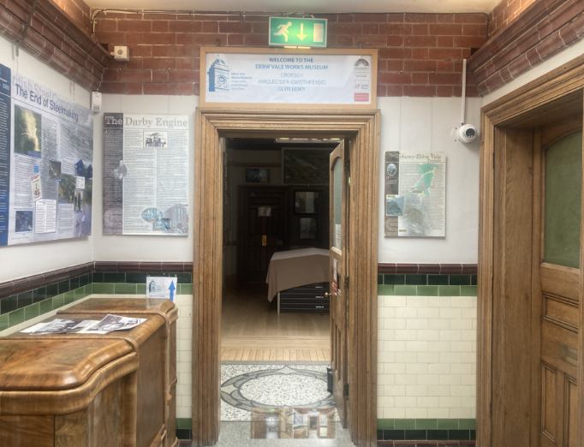
Image 11: Entrance to the museum
Continue through the museum, through another door
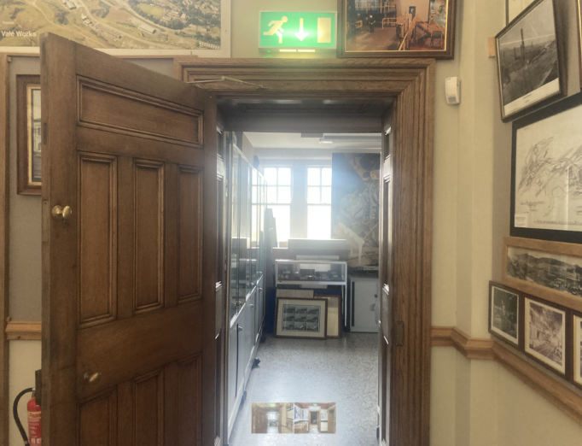
Image 12: Second door through the museum
and the bathroom is immediately on the right
Both accessible bathrooms are gender neutral.

Food, Drink and Break Rooms
- We do not allow food and drink in the research room. This is to deter pests which could damage the historic material, and to ensure that no food or drink is spilled on our items. You may leave food and water in the lockers outside the room. You can leave your desk any time to eat or drink outside of the research room.
- We do not have a break room. There is a seating area where you can eat a packed lunch. This is the Locker Room, which is just outside the entrance to the Research Room, or you can eat in the Atrium area at the rear of the General Offices. The Atrium tends to be a bit busier and noisier, but there is more seating there.
- There is no café in The General Offices, but refreshments are sold at the main reception. These include hot drinks, cans and water as well as flapjacks, chocolate bars, crisps and biscuits. Payment can be made by cash or card, and the minimum card payment is £1.50.

Sensory Information

Light
- The research room has natural light from very tall windows alongside one of the walls. There are blinds, and these are usually in the ‘up’ position to allow natural light. It is fine to request that the blinds be closed.
- There are windows on the other side of the room too but as these look onto the staff corridor the blinds are kept down on that side to avoid distraction for researchers.
- The research room does use fluorescent overhead lighting, high up in the ceiling to supplement the natural light on darker days.
- You can request a seat near or away from a natural light source by emailing us at enquiries@gwentarchives.gov.uk in advance of your visit or asking a member of staff when you arrive.

Temperature
- We do experience some problems in maintaining a consistent temperature in our Research Room. We aim for temperatures of 18 to 21 degrees Celsius, but they could be considerably warmer in summer and much cooler in winter.
- You can bring mini heating pads into the research room to help you regulate your temperature, but they should be kept away from the documents. We do not allow hot water bottles in our research spaces.
- You can bring a mini fan into the room to help you regulate your temperature, though this should be directed towards the body and not the documents.
- We encourage and allow you to bring an extra clothing into our space with you to help you regulate your body temperature as the temperature cannot be adjusted.

Noise
- The reception area of the General Offices may be busy or noisy if a group visit or training session is taking place that day. Otherwise the space contains people talking but other background activity is low.
- In our research room talking is allowed and you might hear groups discussing projects or talking about their work and people are generally quiet
- On occasion we may show a group on a tour of Gwent Archives through the research room. These only happen infrequently and will not take long.
- Staff will walk through our space pushing trollies, carrying books, and who might be talking. This might be distracting.
- You may also hear some noise from other parts of the building, for example doors closing – sometimes loudly - and the lift near to the Research Room beeps on occasion.
- You are welcome to bring your headphones into the research room with you.
- Fire drills take place when nobody is in the building. We will understand if a fire alarm goes off and causes distress. If the alarm does sound staff will guide you to the nearest exit.

Smell
- Our research room has many different users, so we cannot guarantee a fragrance-free space.
- Cleaning takes place prior to opening, and only water and damp cloths are used to clean the furniture and equipment in this room.
- Our archive documents can also have a strong smell, depending on the material it is made of and previous storage conditions.

Visual Distractions
- There may be visual distractions in our research room, for example staff using the finding aids to aid their work or helping researchers, contractors checking equipment and other users entering and leaving the research room.
- On occasion we may take a group on an ‘Archive Tour’ through the Research Room so that they can see the space
- You can see other people in the building through glass panes.
- People might be moving archival documents through the research space.
- It is ok to get up and walk around if you need to

Our Research Room Etiquette
- Our research room opens at 9:30 and shuts at 16:30.
- We have a break for lunch between 12:30 and 13:30, during which you will be asked to leave the room for an hour. Staff will warn researchers 12:20 and lock the door at the appointed time. You must leave the room during this time and will not be allowed back in until the end of the break.
- We have a locker room where you can use your laptop, drink water, and other things. You are allowed to work here during the lunchtime closure but are not allowed to bring collections material into the space.
- You will not be given an assigned desk unless you have requested a particular desk. If that is the case our staff will show you where this is.
- Desk spaces are sometimes shared, with up to 4 researchers, but if you would prefer to work alone please let us know when you book or when you arrive.
- If you have ordered materials in advance they will be ready for you on your arrival, either on a trolley or issued individually depending on the documents (for example loose papers in bundles will be issued bundle by bundle). If you order documents whilst in the Research Room they will be retrieved by a member of staff and brought to you. The process for ordering is outlined in our Research Room Guide at https://www.gwentarchives.gov.uk/media/ihmps0fe/researchroomvenglish.pdf
- When you are finished with your materials, let staff know and they will return them.
- Photography of our items is permitted, but you will need to fill in a form which tells us what you are photographing for our records and purchase a Photograph License. You can ask for the form at the archive desk, and payment can be made by card, with cash or cheque. The current cost of a Photograph License can be found at https://www.gwentarchives.gov.uk/en/fees-and-charges/
- In our research room we ask there is no problem with talking quietly.
- The room is free to come and go in as you need.
- Please use our space as you need to. If for any reason you prefer to step out of the room please do so. If you plan to leave temporarily, let one of the staff know so we can reserve your materials for you.
- When you leave the research room it is customary to show your open laptop or notebook to the person sitting at the desk or a security guard – they do not want to see your work, this is to show them that you have not taken any documents away with you.
- We may ask you to show your open laptop or notebook when leaving the research room.

Quiet Spaces
We are aware that at times our spaces can be overwhelming. Archival days can be long and it can be difficult to regulate given the different spaces you are in.
- If you need to leave suddenly for any reason, our staff will understand.
- If you plan to leave temporarily, let one of the staff know so we can keep your materials for you.
- The Research Room is generally quieter and less busy at the start of the day and towards the end of the day. If you want to ask about the best time for you to come please contact us at enquiries@gwentarchives.gov.uk and we’ll be able to provide more specific information to help you plan your visit.

Who was this guide developed by?
We would like to acknowledge that this work was supported by the UKRI and the British Academy Funding through the Equality Diversity and Inclusion Caucus (ES/X008444/1). The funded project this emerged from, Divergent Minds in the Archive, was a collaborative effort between colleagues at Liverpool John Moores University and Robert Gordon University.
This guide was led by Ann-Marie Foster at Robert Gordon University, in collaboration with colleagues at Gwent Archives, Imperial War Museums, and Tyne and Wear Archives, and the input of an Advisory Board.
The template for the guide is freely available under a CC-BY-NC-SA 4.0 license. Archives, libraries, and collections managers can use and adapt it for their own institution.

