**Crowd Cymru Project Report**

01 July 2024 – 31 March 2025

Welsh Government funding phase

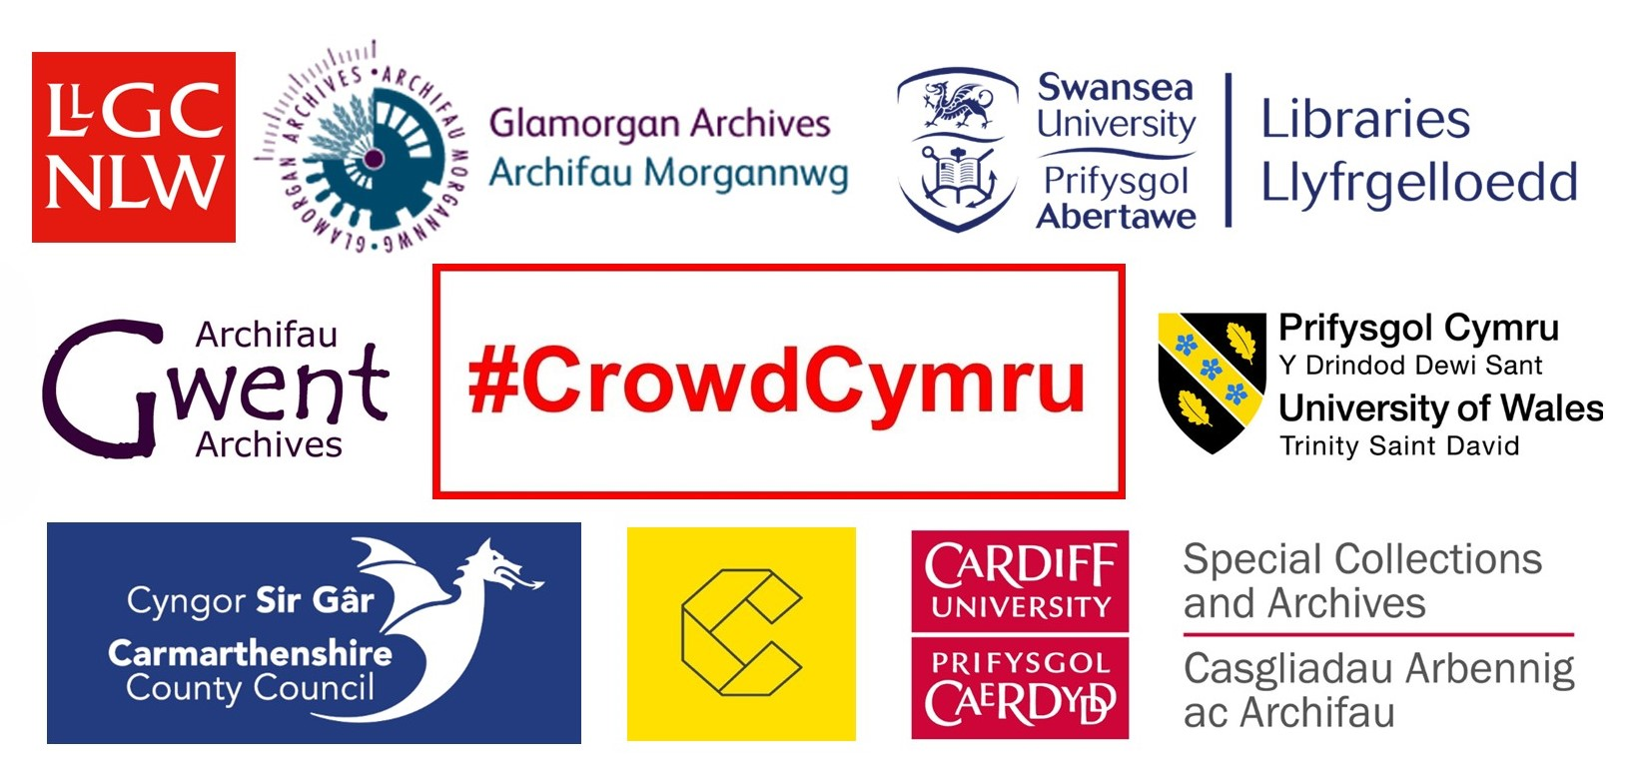

**Contents**

**1. Introduction**

**2. Project approach**

2.1 Recruiting volunteers

2.2 Volunteer registration

2.3 Supporting volunteers

2.4 Promotion

2.5 Outreach

2.6 We are fully bilingual

**3. Feedback survey**

**4. Heritage collections**

**5. Useful links**

**6. Contact details**

31 March 2025

1. **Introduction**

Crowd Cymru is a partnership established in 2022 by [Cardiff University Special Collections and Archives](https://www.cardiff.ac.uk/special-collections), [Glamorgan Archives](https://eur03.safelinks.protection.outlook.com/?url=https%3A%2F%2Fglamarchives.gov.uk%2F&data=05%7C01%7CJennifer.Evans%40gwentarchives.gov.uk%7C4dd12ddfcbe942e569f608dbea7bf63f%7C2c4d0079c52c4bb3b3cad8eaf1b6b7d5%7C0%7C0%7C638361590355088091%7CUnknown%7CTWFpbGZsb3d8eyJWIjoiMC4wLjAwMDAiLCJQIjoiV2luMzIiLCJBTiI6Ik1haWwiLCJXVCI6Mn0%3D%7C3000%7C%7C%7C&sdata=z7vn2Wt4aJYjKv%2BtqMTge4P5zjIvKPFMykutmfPNxO8%3D&reserved=0), [,](https://eur03.safelinks.protection.outlook.com/?url=https%3A%2F%2Fwww.cardiff.ac.uk%2Fspecial-collections&data=05%7C01%7CJennifer.Evans%40gwentarchives.gov.uk%7C4dd12ddfcbe942e569f608dbea7bf63f%7C2c4d0079c52c4bb3b3cad8eaf1b6b7d5%7C0%7C0%7C638361590355244393%7CUnknown%7CTWFpbGZsb3d8eyJWIjoiMC4wLjAwMDAiLCJQIjoiV2luMzIiLCJBTiI6Ik1haWwiLCJXVCI6Mn0%3D%7C3000%7C%7C%7C&sdata=KJhMtDbvhp9o6j1NHe849BsRlT%2BcSWpAqVdz9HrIg5I%3D&reserved=0) [Gwent Archives](https://gwentarchives.gov.uk/en/home/) and [The National Library Wales](https://eur03.safelinks.protection.outlook.com/?url=https%3A%2F%2Fwww.library.wales%2F&data=05%7C01%7CJennifer.Evans%40gwentarchives.gov.uk%7C4dd12ddfcbe942e569f608dbea7bf63f%7C2c4d0079c52c4bb3b3cad8eaf1b6b7d5%7C0%7C0%7C638361590355244393%7CUnknown%7CTWFpbGZsb3d8eyJWIjoiMC4wLjAwMDAiLCJQIjoiV2luMzIiLCJBTiI6Ik1haWwiLCJXVCI6Mn0%3D%7C3000%7C%7C%7C&sdata=W%2BdYH4APWuaF%2BYAsgliwMQjqE%2Fvezz%2FjXZesG5TPYsY%3D&reserved=0) to deliver an ambitious digital volunteering project for Welsh archives. In November 2024 we welcomed 4 new heritage partners: [Carmarthenshire Archives](https://eur03.safelinks.protection.outlook.com/?url=https%3A%2F%2Fwww.carmarthenshire.gov.wales%2Fhome%2Fcouncil-services%2Flibraries-archives%2Fcarmarthenshire-archives%2F&data=05%7C02%7CNeta.whitehead%40gwentarchives.gov.uk%7C471d408b0ad64dce0b7108dce160f6e8%7C2c4d0079c52c4bb3b3cad8eaf1b6b7d5%7C0%7C0%7C638633053779914962%7CUnknown%7CTWFpbGZsb3d8eyJWIjoiMC4wLjAwMDAiLCJQIjoiV2luMzIiLCJBTiI6Ik1haWwiLCJXVCI6Mn0%3D%7C0%7C%7C%7C&sdata=a8BPdw3eers1XZK7y2O6Uk5lAqEKJdGzkD5Tgna2Xj4%3D&reserved=0), [Conwy Culture | Conwy Archives](https://eur03.safelinks.protection.outlook.com/?url=https%3A%2F%2Fconwyculture.com%2Fvisit-culture%2Fconwy-archives&data=05%7C02%7CNeta.whitehead%40gwentarchives.gov.uk%7C471d408b0ad64dce0b7108dce160f6e8%7C2c4d0079c52c4bb3b3cad8eaf1b6b7d5%7C0%7C0%7C638633053779888410%7CUnknown%7CTWFpbGZsb3d8eyJWIjoiMC4wLjAwMDAiLCJQIjoiV2luMzIiLCJBTiI6Ik1haWwiLCJXVCI6Mn0%3D%7C0%7C%7C%7C&sdata=5EOpXj8rZJ57smGRSbhJCBqcbUjWwotp1%2BY3CFggZJk%3D&reserved=0), [Swansea University Libraries and Archives](https://eur03.safelinks.protection.outlook.com/?url=https%3A%2F%2Fwww.swansea.ac.uk%2Flibrary%2F&data=05%7C02%7CNeta.whitehead%40gwentarchives.gov.uk%7C471d408b0ad64dce0b7108dce160f6e8%7C2c4d0079c52c4bb3b3cad8eaf1b6b7d5%7C0%7C0%7C638633053779940935%7CUnknown%7CTWFpbGZsb3d8eyJWIjoiMC4wLjAwMDAiLCJQIjoiV2luMzIiLCJBTiI6Ik1haWwiLCJXVCI6Mn0%3D%7C0%7C%7C%7C&sdata=%2BYFZ%2B%2FyyznSZZXRkG6jG29E3kF%2FvxtIpDcTIi7zeibI%3D&reserved=0) and [University of Wales Trinity St Davids Special Collections and Archives.](https://eur03.safelinks.protection.outlook.com/?url=https%3A%2F%2Fwww.uwtsd.ac.uk%2Flibrary%2Fspecial-collections-and-archives&data=05%7C02%7CNeta.whitehead%40gwentarchives.gov.uk%7C471d408b0ad64dce0b7108dce160f6e8%7C2c4d0079c52c4bb3b3cad8eaf1b6b7d5%7C0%7C0%7C638633053779959461%7CUnknown%7CTWFpbGZsb3d8eyJWIjoiMC4wLjAwMDAiLCJQIjoiV2luMzIiLCJBTiI6Ik1haWwiLCJXVCI6Mn0%3D%7C0%7C%7C%7C&sdata=4n3zpTLCeLbrBJrt2FoDNPEGqTaPZQ53Lgnn1Zgzuok%3D&reserved=0)

Previously funded by the [National Lottery Heritage Fund,](https://eur03.safelinks.protection.outlook.com/?url=https%3A%2F%2Fwww.heritagefund.org.uk%2F&data=05%7C01%7CJennifer.Evans%40gwentarchives.gov.uk%7C4dd12ddfcbe942e569f608dbea7bf63f%7C2c4d0079c52c4bb3b3cad8eaf1b6b7d5%7C0%7C0%7C638361590355088091%7CUnknown%7CTWFpbGZsb3d8eyJWIjoiMC4wLjAwMDAiLCJQIjoiV2luMzIiLCJBTiI6Ik1haWwiLCJXVCI6Mn0%3D%7C3000%7C%7C%7C&sdata=CSlRfgqodEQqooMrrQwQCNoQpE0WJeYBMvRK5zTHHhg%3D&reserved=0) National Lottery Players, and The National Library Wales, the current phase is funded by [Welsh Government](https://www.gov.wales/) until 31 March 2025.

The idea for the project was born from a need to demonstrate that as project partners we were taking a proactive and collaborative approach to collectively modernise our services to meet the ambitious roadmap of [Welsh Government’s Digital Strategy of Wales](https://www.gov.wales/digital-strategy-wales-delivery-plan?url=https%3A%2F%2Fwww.llyw.cymru%2Fstrategaeth-ddigidol-i-gymru-cynllun-cyflawni&data=05%7C01%7CJennifer.Evans%40gwentarchives.gov.uk%7C4dd12ddfcbe942e569f608dbea7bf63f%7C2c4d0079c52c4bb3b3cad8eaf1b6b7d5%7C0%7C0%7C638361590355244393%7CUnknown%7CTWFpbGZsb3d8eyJWIjoiMC4wLjAwMDAiLCJQIjoiV2luMzIiLCJBTiI6Ik1haWwiLCJXVCI6Mn0%3D%7C3000%7C%7C%7C&sdata=S2BrAyEHm1aJ7uac7ycmKq0hWgr6%2B%2F8EmyeogL%2BJMSA%3D&reserved=0), which aims to “*improve the lives of everyone through collaboration, innovation and better public services*”.

Using a bi-lingual online platform developed by The National Library Wales, we recruited volunteers from across Wales and the world to tag, index and transcribe digital copies of archive collections to help make them more accessible for future researchers and wider celebration. Crowd Cymru equips people with new digital skills to be better connected across their communities, and to develop their confidence to seek new digital opportunities in the workplace and for wellbeing. Moreover, the project paves the way for archive services to develop new agile models for remote volunteering to avoid the need for travel, and to support Welsh Government’s ambition to reduce our carbon footprint.

Thanks to funding from the Welsh Government, this phase has been one of growth and expansion. Our Crowd Cymru family is proud to welcome four new partners, each contributing rich histories and heritage to enhance and inspire the project. They also bring with them new digital collections, offering further opportunities for our dedicated volunteers to uncover more remarkable stories. Our aim for the future is to continue the important work of enhancing the quality and accessibility of historical digital collections, providing a positive experience for our volunteers, and expanding our wonderful crowdsourcing community.

This report shares the progress, learning and best practice from the project.

A report covering the first phase, along with all previous activities, is found on our project web page: [#CrowdCymru | Gwent Archives](https://gwentarchives.gov.uk/en/partnership-and-projects/crowdcymru/)

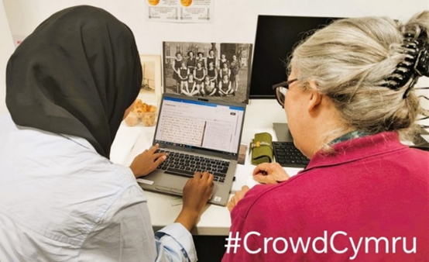If you are an organisation who would like to join us as a future partner, or an individual who would like to volunteer with us, please contact our Project Officer, Jennifer Evans:

**Email:** [jennifer.evans@gwentarchives.gov.uk](mailto:jennifer.evans@gwentarchives.gov.uk)

**Phone:** 01495 74245

1. **Project approach**

**2.1 Recruiting volunteers**

We have an established group of nearly 100 people who volunteer with us on the project.

Our volunteers are primarily based in Wales, with a few located in the USA and Canada.

Our volunteers were recruited using several methods:

* Emails sent to archive organisations and local history groups
* Social media activity via an X account
* Collaboration with established archive networks including [Archives & Records Association,](https://www.archives.org.uk/) [Archives Wales](https://archives.wales/) and [WCVA](https://wcva.cymru/volunteering/)

**2.2 Volunteer registration**

Although volunteers can directly register via the [Crowd Cymru digital platform](https://torf2.llyfrgell.cymru/s/crowd-cymru/about), we encourage registration through direct contact with the Project Officer so that volunteers are included in regular project communications and receive information about training and online social events.

**2.3 Supporting volunteers**

**Monthly newsletter** - Our volunteers receive a monthly email containing project information to highlight new collections to work on, guidelines on the type of data collection required, and links to items of possible interest. The newsletter keeps our volunteers updated on project news and also offers regular interaction for those who take part to combat loneliness and social isolation.

**Training** – We provide regular online group training sessions, and we offer 1-2-1 sessions for those who either can’t make the set times, or who prefer to work alone.

**Facebook group** – All volunteers are invited to join a closed Facebook group where they can connect with each other, read items of interest and interact with posts by the project team. However, our volunteers who do not wish to engage with social media won’t miss anything of significance as all essential project updates are communicated via the monthly newsletter.

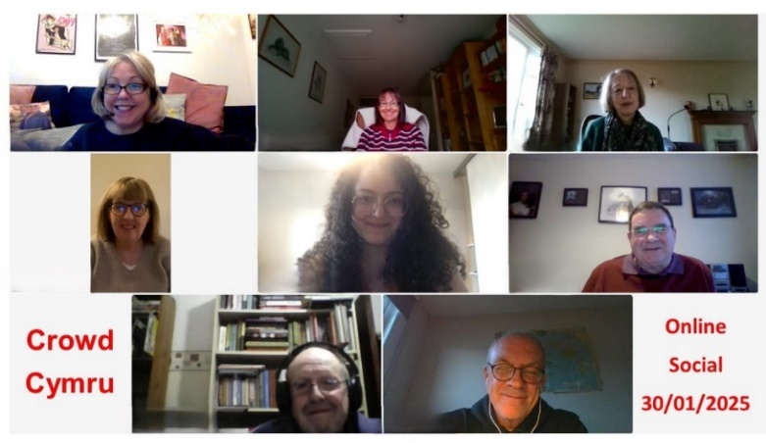

**Online socials** - Every few months the Project Officer sends out a selection of dates via Doodle Poll and selects the most popular date to host an online social get-together. Our last social was in January where (unsurprisingly) Christmas was the dominant topic!

**2.4 Promotion**

**Social media** – Our X account was established in September 2022 to promote project progress, highlight collections and support wider partners across the archive, library, museum, and heritage sector: <https://x.com/crowdcymru>.

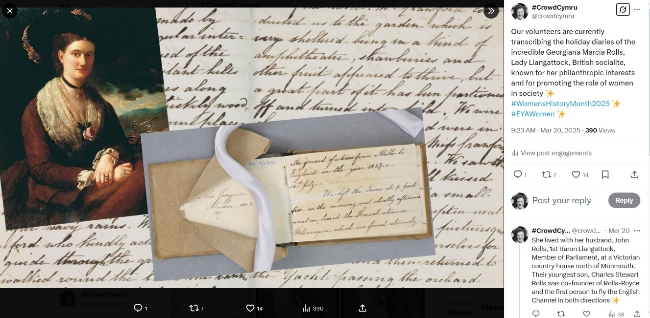

**Blog posts** - During the first phase of the project we published 5 blog posts on the Archives Wales website to report on project progress and share stories. You can read them [here](https://archives.wales/) by typing “Crowd Cymru” in the search box located in the top right-hand corner of the homepage.

We also contributed several blogposts to The National Library Wales website, including this one to celebrate the story of a formidable character appearing in multiple archive collections: [Connections through digital archives: the life of Blanche Baker-Gabb as seen through Crowd Cymru, The National Library Wales Archive and the Welsh Women’s Peace Petition. - National Library of Wales](https://www.library.wales/news/article/connections-through-digital-archives-the-life-of-blanche-baker-gabb-as-seen-through-crowd-cymru-national-library-wales-archive-and-the-welsh-womens-peace-petition).

This year we also contributed the following piece to the Wales Council for Voluntary Action website: [Bringing Wales’ past into the 21st century - WCVA](https://wcva.cymru/views/bringing-wales-past-into-the-21st-century/).

**Magazine articles** – We contributed an article to the October 2024 edition of the [Amgueddfa Cymru Friends Magazine](https://gwentarchives.gov.uk/media/wgyngkt4/oriel-cyfeillion-amgueddfa-cymru-friends-hydref-oct-2024_compressed-1.pdf), and our second article to the April 2024 edition of [Who Do You Think You Are?](https://www.whodoyouthinkyouaremagazine.com/magazine).

**2.5 Outreach**

Whenever possible we try to give face to face talks to any heritage or local groups who request a talk. However, if distance is a challenge, we always offer an online presentation as an alternative. For example, below you can see a photo of our Project Officer at a recent talk for Glamorgan Family History Society (Bridgend Branch) in Aberkenfig.

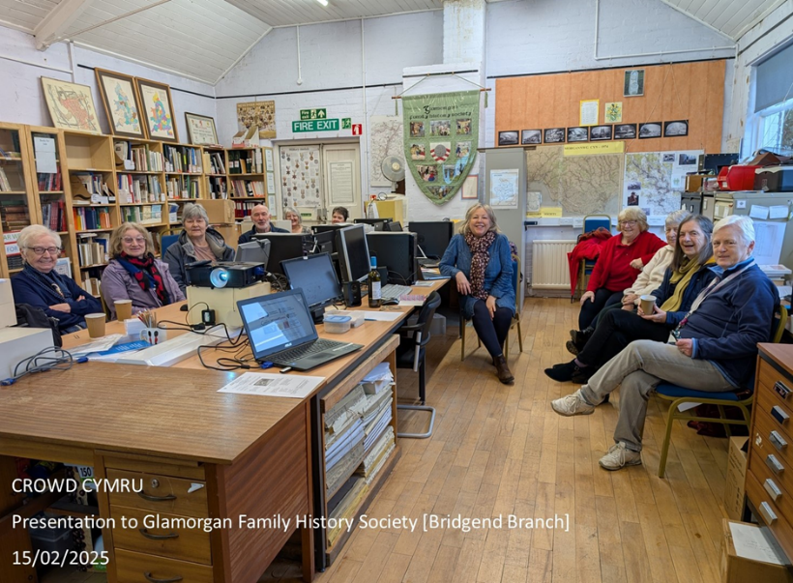

As well as talks, we also regularly attend community events to share project information and chat to potential volunteers. The photos below show our Project Officer at the meet and greet table during Dementia Awareness Day at St Fagans National Museum of History (June 2023) and at the AGM of the Gwent Federation of the Women’s Institute (April 2024).

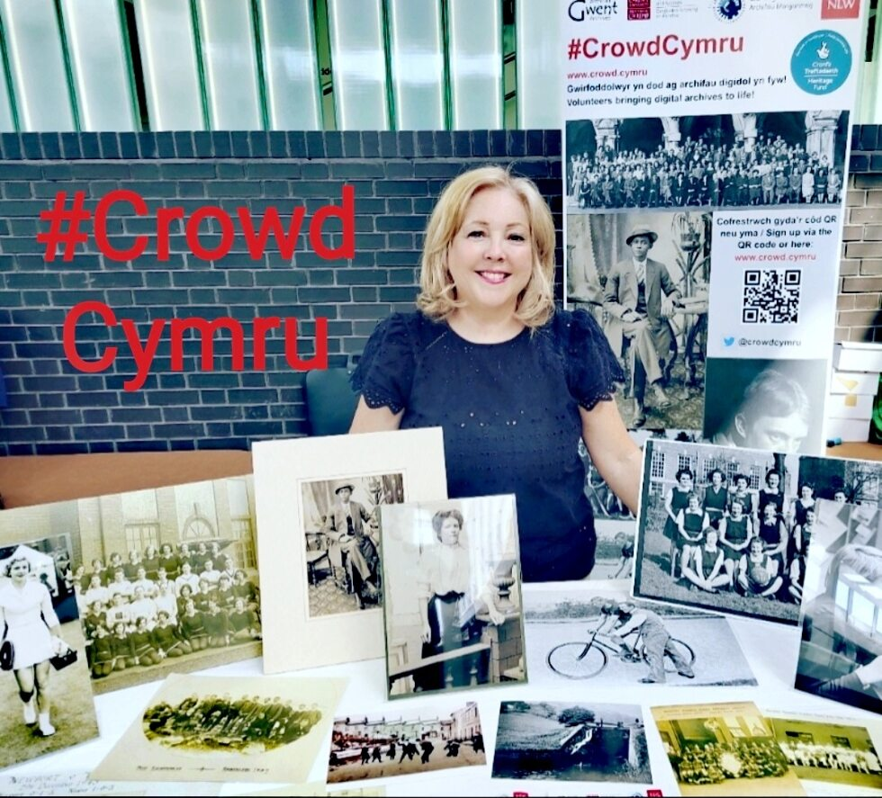 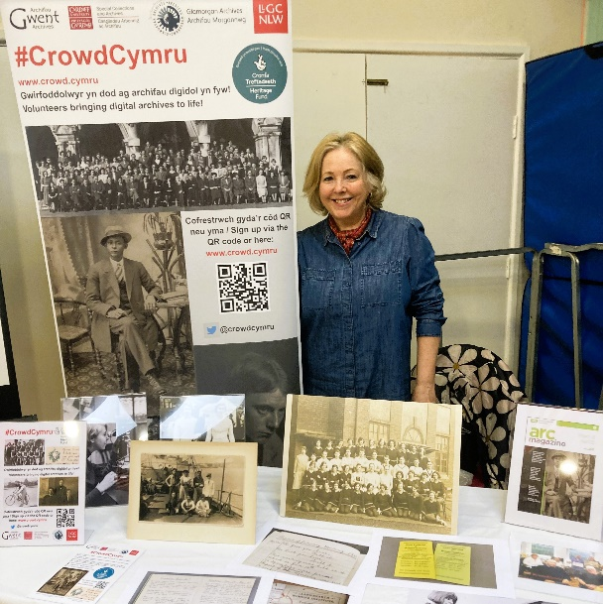

* 1. **We are fully bilingual**

[Welsh Language Act 1993 | Law Wales](https://law.gov.wales/culture/welsh-language/welsh-language-act-1993)

We are a fully bilingual project as all partners are all public or higher education organisations in Wales where the Welsh language is treated no less favourably than English. Therefore, everything we create and publish is posted in Welsh first, as seen here in our most recent flyer design.

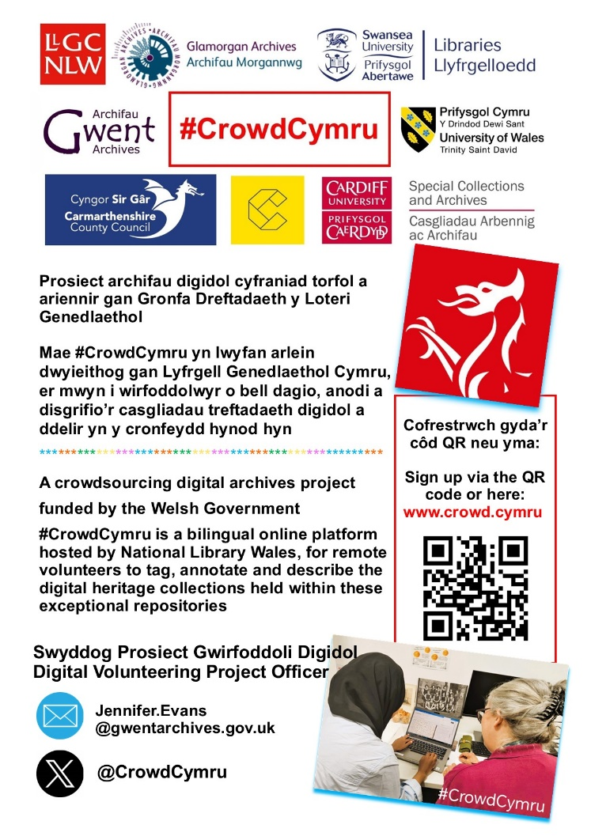

1. **Feedback survey**

During the first phase of the project, we shared an electronic volunteer feedback survey as part of ongoing project evaluation and post-project review. This gave us valuable insights into the project's impact and helped us to identify areas for improvement – a summary of the findings is available in the [Project Handbook](https://gwentarchives.gov.uk/media/obifsafn/crowd-cymru-project-handbook-english.pdf).

We sent an additional survey in March this year, where we emailed our volunteers to ask about the overall quality of the project and their experience of volunteering with us. We wanted to learn what we are doing right, where we are falling short, and how we can improve.

Feedback so far has been encouraging:

*How would you rate your #CrowdCymru experience so far?* ***90% Very good / 10% Good***

*How likely are you to recommend this project to others?* ***80% Very likely / 20% Likely***

*Have you learnt new skills?* ***100% Yes***

*Do you now feel more confident at using IT?* ***100% Yes***

*Has your sense of wellbeing improved?* ***100% Yes***

*Have you felt adequately supported by the Project Officer since registering?* ***100% Yes***

**4. Heritage collections**

Here is a list of the digital collections our volunteers have worked on:

|  |  |
| --- | --- |
| **Logbook of St David's College, Lampeter**  Handwritten account of day-to-day college life circa 1875-1886.  Archive: University of Wales Trinity Saint David  Status:Transcription in progress  Size: Single volume of 155 doubles pages  Web: [St.David's College, Lampeter : minutes Sept 1875-1886. - University of Wales Trinity Saint David](https://librarysearch.uwtsd.ac.uk/discovery/fulldisplay?docid=alma99100669985302421&context=L&vid=44WHELF_UWTSD:44WHELF_UWTSD_VU1&lang=en&search_scope=MyInst_and_CI&adaptor=Local%20Search%20Engine&tab=Everything&query=any,contains,Logbook%20of%20St%20David%27s%20College%20%20Lampeter%20) |  |
| **Edwin Miles Photographic Collection**  A collection of black and white photographic glass plate negatives of Bridgend and the Vale of Glamorgan taken by Edwin Miles during 1900-1929 to produce postcards.  Archive: Glamorgan Archives  Status: Tagging in progress  Size: 456 photographs  Web: [Edwin Miles Photographic Collection](https://canfod.glamarchives.gov.uk/en/records/D261) |  |
| **Cardiff University Institutional Photos**  A photographic history of Cardiff University containing images of academic schools, buildings, staff, students, and views of the estate.  Archive: Cardiff University Special Collections  Status: Tagging in progress  Size: 498 photographs  Web: [Cardiff University photographic archive - Cardiff University and NHS Wales Libraries](https://whelf-cardiff.alma.exlibrisgroup.com/discovery/collectionDiscovery?vid=44WHELF_CAR:44WHELF_CAR_VU1&collectionId=81204071960002420) |  |
| **Cardiff University student magazines**  Whimsical handwritten reports of daily college life 1885-1888.  Archive: Cardiff University Special Collections  Status: Transcription in progress  Size: 11 volumes totalling 1412 pages  Web: [Student newspapers and magazines of Cardiff University and its predecessors, 1885-current - Archives Hub](https://archiveshub.jisc.ac.uk/search/archives/f5c555d0-9028-335d-9111-15f6d4e8b156?component-id=ca7d4b11-889b-38c4-92a1-49f21e3fb9ca&terms=71) |  |
| **Rolls Family Archive**  Documents from the Rolls Family; includes holiday diaries from Georgiana Rolls, whose youngest son Charles was co-founder of Rolls-Royce and the first to fly the English Channel in both directions.  Archive: Gwent Archives  Status: Transcription in progress  Size: 9 items totalling 544 double pages  Web: [Rolls family (Barons Llangattock), of The Hendre, documents [c. 1617]-1952GB0218.D361](https://gwentarchives.gov.uk/media/kbwhlx3b/d361-rolls-family-barons-llangattock-of-the-hendre.html) |  |
| **Edward Thomas diaries and letters**  Diaries and letters by one of the lesser known First World War poets, Edward Thomas, 1878-1917.  Archive: The National Library of Wales  Status: Transcription in progress  Size: 13 items totalling 2054 pages  Web: [Edward and Helen Thomas manuscripts - National Library of Wales](https://www.library.wales/catalogues-searching/about-our-collections/archives/archives-of-welsh-writers-in-english/edward-and-helen-thomas-manuscripts) |  |
| **Cardiff Dockland Collection**  Portraits of individuals and groups from the Cardiff dockland community taken between 1900-1920; many taken by Fred Petersen notable for portraying Black and mixed heritage children and families from Cardiff’s diverse dock community.  Archive: Glamorgan Archives  Status: Tagging completed  Size: 74 photographs  Web: [Cardiff’s docklands community photographs](https://glamarchives.gov.uk/cardiffs-docklands-community-photographs/) |  |
| **Newport Athletics & Rugby Club Archive**  A photographic history of the club from 1884.  Archive: Gwent Archives  Status: Tagging completed  Size: 49 photographs  Web: [GB0218.D1836GB0218.D1836](https://gwentarchives.gov.uk/media/sqff1agr/d1836-newport-harriers.html) |  |
| **Gwent Lesbian and Gay Group**  Newsletters and posters; established in 1986, the Gwent Lesbian and Gay Group wanted to offer an alternative to the Cardiff gay scene and organised monthly discos and meetings disseminating information on HIV and AIDS.  Archive: Gwent Archives  Status: Transcription completed  Size: 49 images  Web: [Gwent Lesbian and Gay Group PDF [D6466]](https://gwentarchives.gov.uk/media/xzdjntta/d6466-gwent-lesbian-and-gay-group.pdf) |  |
| **Llanwenarth Women’s Institute Minute Books**  Minutes books from the Llanwenarth WI covering the period 1919-1923; Llanwenarth is a small village parish in the Usk valley, Monmouthshire.  Archive: Gwent Archives  Status: Transcription in progress  Size: 3 volumes totalling 202 double pages  Web: [GB0218.D4629](https://gwentarchives.gov.uk/media/ftfnncjm/d4629-monmouthshire-records-of-womens-institute-branches-closed.html#ref383) |  |
| **Priscilla Scott-Ellis's wartime diaries**  Nine personal diaries written by Priscilla Scott-Ellis, who volunteered as a nurse during both the Spanish Civil War & WWII  Archive: Cardiff University Special Collections  Status: Transcription completed  Size: 10 diaries totalling 1723 pages  Web: [Diaries of Priscilla Scott-Ellis (1916-1983), Spanish Civil War nurse - Archives Hub](https://archiveshub.jisc.ac.uk/search/archives/c570ebb8-3d21-375e-aed3-088e2c85d355) |  |
| **Edward Thomas Literary Archive**  Diaries and letters by one of the lesser known war poets, Edward Thomas, 1878-1917.  Archive: Cardiff University Special Collections  Status: Transcription completed  Size: 467 letters  Web: [Edward Thomas archive - Special Collections and Archives - Cardiff University](https://www.cardiff.ac.uk/special-collections/explore/archives/edward-thomas-archive) |  |

**5. Useful links**

Project web page: [#CrowdCymru | Gwent Archives](https://gwentarchives.gov.uk/en/partnership-and-projects/crowdcymru/)

Project digital volunteering platform: [Crowd Cymru](https://torf2.llyfrgell.cymru/s/crowd-cymru)

Project partners:

[Cardiff University Special Collections and Archives](https://www.cardiff.ac.uk/special-collections)

[Carmarthenshire Archives](https://eur03.safelinks.protection.outlook.com/?url=https%3A%2F%2Fwww.carmarthenshire.gov.wales%2Fhome%2Fcouncil-services%2Flibraries-archives%2Fcarmarthenshire-archives%2F&data=05%7C02%7CNeta.whitehead%40gwentarchives.gov.uk%7C471d408b0ad64dce0b7108dce160f6e8%7C2c4d0079c52c4bb3b3cad8eaf1b6b7d5%7C0%7C0%7C638633053779914962%7CUnknown%7CTWFpbGZsb3d8eyJWIjoiMC4wLjAwMDAiLCJQIjoiV2luMzIiLCJBTiI6Ik1haWwiLCJXVCI6Mn0%3D%7C0%7C%7C%7C&sdata=a8BPdw3eers1XZK7y2O6Uk5lAqEKJdGzkD5Tgna2Xj4%3D&reserved=0)

[Conwy Culture | Conwy Archives](https://eur03.safelinks.protection.outlook.com/?url=https%3A%2F%2Fconwyculture.com%2Fvisit-culture%2Fconwy-archives&data=05%7C02%7CNeta.whitehead%40gwentarchives.gov.uk%7C471d408b0ad64dce0b7108dce160f6e8%7C2c4d0079c52c4bb3b3cad8eaf1b6b7d5%7C0%7C0%7C638633053779888410%7CUnknown%7CTWFpbGZsb3d8eyJWIjoiMC4wLjAwMDAiLCJQIjoiV2luMzIiLCJBTiI6Ik1haWwiLCJXVCI6Mn0%3D%7C0%7C%7C%7C&sdata=5EOpXj8rZJ57smGRSbhJCBqcbUjWwotp1%2BY3CFggZJk%3D&reserved=0)

[Glamorgan Archives](https://eur03.safelinks.protection.outlook.com/?url=https%3A%2F%2Fglamarchives.gov.uk%2F&data=05%7C01%7CJennifer.Evans%40gwentarchives.gov.uk%7C4dd12ddfcbe942e569f608dbea7bf63f%7C2c4d0079c52c4bb3b3cad8eaf1b6b7d5%7C0%7C0%7C638361590355088091%7CUnknown%7CTWFpbGZsb3d8eyJWIjoiMC4wLjAwMDAiLCJQIjoiV2luMzIiLCJBTiI6Ik1haWwiLCJXVCI6Mn0%3D%7C3000%7C%7C%7C&sdata=z7vn2Wt4aJYjKv%2BtqMTge4P5zjIvKPFMykutmfPNxO8%3D&reserved=0)

[Gwent Archives](https://gwentarchives.gov.uk/en/home/)

[National Library Wales](https://eur03.safelinks.protection.outlook.com/?url=https%3A%2F%2Fwww.library.wales%2F&data=05%7C01%7CJennifer.Evans%40gwentarchives.gov.uk%7C4dd12ddfcbe942e569f608dbea7bf63f%7C2c4d0079c52c4bb3b3cad8eaf1b6b7d5%7C0%7C0%7C638361590355244393%7CUnknown%7CTWFpbGZsb3d8eyJWIjoiMC4wLjAwMDAiLCJQIjoiV2luMzIiLCJBTiI6Ik1haWwiLCJXVCI6Mn0%3D%7C3000%7C%7C%7C&sdata=W%2BdYH4APWuaF%2BYAsgliwMQjqE%2Fvezz%2FjXZesG5TPYsY%3D&reserved=0)

[Swansea University Libraries and Archives](https://eur03.safelinks.protection.outlook.com/?url=https%3A%2F%2Fwww.swansea.ac.uk%2Flibrary%2F&data=05%7C02%7CNeta.whitehead%40gwentarchives.gov.uk%7C471d408b0ad64dce0b7108dce160f6e8%7C2c4d0079c52c4bb3b3cad8eaf1b6b7d5%7C0%7C0%7C638633053779940935%7CUnknown%7CTWFpbGZsb3d8eyJWIjoiMC4wLjAwMDAiLCJQIjoiV2luMzIiLCJBTiI6Ik1haWwiLCJXVCI6Mn0%3D%7C0%7C%7C%7C&sdata=%2BYFZ%2B%2FyyznSZZXRkG6jG29E3kF%2FvxtIpDcTIi7zeibI%3D&reserved=0)

[University of Wales Trinity Saint David Special Collections and Archives](https://eur03.safelinks.protection.outlook.com/?url=https%3A%2F%2Fwww.uwtsd.ac.uk%2Flibrary%2Fspecial-collections-and-archives&data=05%7C02%7CNeta.whitehead%40gwentarchives.gov.uk%7C471d408b0ad64dce0b7108dce160f6e8%7C2c4d0079c52c4bb3b3cad8eaf1b6b7d5%7C0%7C0%7C638633053779959461%7CUnknown%7CTWFpbGZsb3d8eyJWIjoiMC4wLjAwMDAiLCJQIjoiV2luMzIiLCJBTiI6Ik1haWwiLCJXVCI6Mn0%3D%7C0%7C%7C%7C&sdata=4n3zpTLCeLbrBJrt2FoDNPEGqTaPZQ53Lgnn1Zgzuok%3D&reserved=0)

Funded by: [Home | GOV.WALES](https://www.gov.wales/)

**6. Contact details**

**Project Officer**

Jennifer Evans

01495 74245 | [jennifer.evans@gwentarchives.gov.uk](mailto:jennifer.evans@gwentarchives.gov.uk)

**Platform management and technical Support**

Paul McCann  
Rheolwr Prosiectau Ymchwil | Research Projects Manager

Llyfrgell Genedlaethol Cymru | The National Library of Wales  
01970 632423 | [paul.mccann@llyfrgell.cymru](mailto:paul.mccann@llyfrgell.cymru) | [www.llyfrgell.cymru](https://eur03.safelinks.protection.outlook.com/?url=https%3A%2F%2Fwww.llyfrgell.cymru%2F&data=05%7C02%7CJennifer.Evans%40gwentarchives.gov.uk%7C0853bfb1947b4c401fdf08dd6d14d8d1%7C2c4d0079c52c4bb3b3cad8eaf1b6b7d5%7C0%7C0%7C638786658486511679%7CUnknown%7CTWFpbGZsb3d8eyJFbXB0eU1hcGkiOnRydWUsIlYiOiIwLjAuMDAwMCIsIlAiOiJXaW4zMiIsIkFOIjoiTWFpbCIsIldUIjoyfQ%3D%3D%7C0%7C%7C%7C&sdata=V8r14QtYsNuF5hjolhTf21Ezo1d5X5Jn0qznrQIHHKg%3D&reserved=0)

Bethan Rees  
Rheolwr Rhaglen Ddigidol | Digital Program Manager

Llyfrgell Genedlaethol Cymru | The National Library of Wales  
Aberystwyth, Ceredigion SY23 3BU

01970 632998 | [bethan.rees@llyfrgell.cymru](mailto:bethan.rees@llyfrgell.cymru) | [www.llyfrgell.cymru](https://eur03.safelinks.protection.outlook.com/?url=https%3A%2F%2Fwww.llyfrgell.cymru%2F&data=05%7C02%7CJennifer.Evans%40gwentarchives.gov.uk%7Cd11e4a39c0b3409c53dc08dd6c8f4afd%7C2c4d0079c52c4bb3b3cad8eaf1b6b7d5%7C0%7C0%7C638786084894266127%7CUnknown%7CTWFpbGZsb3d8eyJFbXB0eU1hcGkiOnRydWUsIlYiOiIwLjAuMDAwMCIsIlAiOiJXaW4zMiIsIkFOIjoiTWFpbCIsIldUIjoyfQ%3D%3D%7C0%7C%7C%7C&sdata=BqnDGu7BKzKbOkahlsMsAC77t9XohUX4RiZX7QolNjg%3D&reserved=0)

